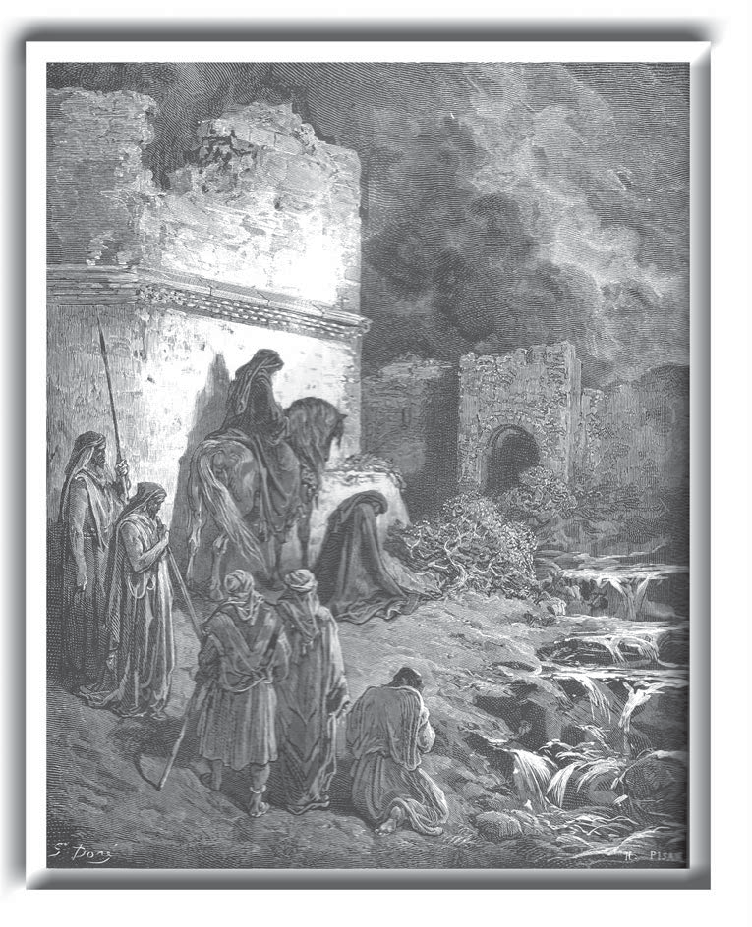

NEHEMIAH
“I set out during the night with a few men. I had not told anyone what my God had put in my heart to do for Jerusalem. There were no mounts with me except the one I was riding on. By night I went out through the Valley Gate towards the Jackal Well and the Dung Gate, examining the walls of Jerusalem, which had been broken down, and its gates, which had been destroyed by fire.”
Nehemiah 2:12,13 NIV

This study has been prepared by Bob Walz and Ben Chesnut. The explanation of How to Study the Scriptures was written by Brandon Levering and is used by permission.
© 2006 Bob Walz and Ben Chesnut
Price: $10.00 (All proceeds go the the general activities fund of the UNL Navigators, which pays for the cost of these studies, other publications, administrationa and events).

Table of Contents

How to Study the Scriptures by Brandon Levering . . . . . . . . . . . . . . . . . . . . . . . . . . . . . . . . . . . pages 2-6

One - The Scouting Report . . . . . . . . . . . . . . . . . . . . . . . . . . . . . . . . . . . . . . . . . . . . . . . . . . . . . . . .pages 7,8
Week

Two - A Survey of Nehemiah . . . . . . . . . . . . . . . . . . . . . . . . . . . . . . . . . . . . . . . . . . . . . . . . . . . . . pages 9-13
Week
Three - Nehemiah Chapter 1 . . . . . . . . . . . . . . . . . . . . . . . . . . . . . . . . . . . . . . . . . . . . . . . . . . . . pages 14-17
Week
Four - Nehemiah Chapter 2 . . . . . . . . . . . . . . . . . . . . . . . . . . . . . . . . . . . . . . . . . . . . . . . . . . . . . pages 18-21
Week
Five - Nehemiah Chapters 3,4 . . . . . . . . . . . . . . . . . . . . . . . . . . . . . . . . . . . . . . . . . . . . . . . . . . . pages 22-25
Week

Six - Nehemiah Chapter 5 . . . . . . . . . . . . . . . . . . . . . . . . . . . . . . . . . . . . . . . . . . . . . . . . . . . . . . pages 26-29
Week

Seven - Nehemiah Chapter 6 . . . . . . . . . . . . . . . . . . . . . . . . . . . . . . . . . . . . . . . . . . . . . . . . . . . . pages 30-33
Week
Eight - Nehemiah Chapters 7,8 . . . . . . . . . . . . . . . . . . . . . . . . . . . . . . . . . . . . . . . . . . . . . . . . . . pages 34-37
Week
Nine - Nehemiah Chapter 9 . . . . . . . . . . . . . . . . . . . . . . . . . . . . . . . . . . . . . . . . . . . . . . . . . . . . . pages 38-41
Week
Ten - Nehemiah Chapters 10,11 . . . . . . . . . . . . . . . . . . . . . . . . . . . . . . . . . . . . . . . . . . . . . . . . . pages 42-45
Week
Eleven - Nehemiah Chapter 12 . . . . . . . . . . . . . . . . . . . . . . . . . . . . . . . . . . . . . . . . . . . . . . . . . . pages 46-49
Week
Twelve - Nehemiah Chapter 13 . . . . . . . . . . . . . . . . . . . . . . . . . . . . . . . . . . . . . . . . . . . . . . . . . . pages 50-53
Week
Thirteen - A Summary of Nehemiah . . . . . . . . . . . . . . . . . . . . . . . . . . . . . . . . . . . . . . . . . . . . . pages 54-57
Week
Fourteen - A Character Study of Nehemiah . . . . . . . . . . . . . . . . . . . . . . . . . . . . . . . . . . . . . . . pages 58-61
Week
Appendix - Leadership Principles in Nehemiah’s Life . . . . . . . . . . . . . . . . . . . . . . . . . . . . . . . pages 62-66

How to Study the Scriptures

by Brandon Levering

When your eyes hit the page and you read a verse of Scripture, what is the ﬁrst thing you should notice about that verse? No doubt there are many observations that could be made, but perhaps the most important one is the fact that in order to read that verse, you had to open an entire book to get to it. Individual verses in the Bible aren’t ﬂoating around by themselves, but are part of a larger collection of books – the Bible. The Bible is the setting in which individual verses are found. Therefore, it is the entire Bible that forms the context and gives meaning to individual verses (or passages or books). This means we must understand how context works in the Bible as a whole. Remember, the book of Nehemiah isn’t an ancient document simply ﬂoating around, but is part of what we call the canon – that is the collection of books recognized as belonging in the Bible.

The Concentric Circles of Context
We must remember that our passage only has context within its chapter, and that chapter only has context within its book, and that book within the Bible. Think of it as a series of concentric circles. We start with the innermost part – our passage – and we work our way out. We can learn much here from the Puritans.
  - Packer says “the Puritans received the Bible as a self-contained and self-interpreting revelation of God’s mind. This revelation, the ‘body of divinity’ as they called it, is, they held, a unity, to which every part of ‘the best of the books’ makes its own distinct contribution. It follows that the meaning of single texts cannot be properly discerned till they are seen in relation to the rest of the ‘body’; and, conversely, that the better one’s grasp of the whole, the more signiﬁcance one will see in each part” ( J.I. Packer, A Quest for Godliness).

Book Chapter
Passage Sentence
WORD
i

How to Study the Scriptures_{(cont)}

by Brandon Levering

To broaden our understanding of biblical context, we will take a look at several diﬀerent “layers” of context, beginning with canonical context – how our passage or book ﬁts into the Bible as a whole.

Canonical Context – the entire Bible
The canon is the whole collection of books recognized as belonging in the Bible. Canonical context is simply understanding how the setting of the whole Bible gives meaning to a particular book or passage. Where does the book of Nehemiah ﬁt into the Bible as a whole? What is its contribution to the whole fabric of Scrip- ture?
To understand this, one must begin to grasp some of the overall characteristics of the Bible. Perhaps the most amazing feature is its uniﬁed message of the Messiah, or Christ. The story of the Bible could be summarized as the “story of the promised blessing through the promised Seed of Abraham who will come forth in the Promised Land as the promised King/Savior” to establish his promised Kingdom and advance it through his chosen people by means of the promised Holy Spirit until His promised return and the promised end of the age & subsequent glory (Vern Steiner). So how does Nehemiah ﬁt into that story? How does it pick up on the themes and message of the previous book (Ezra), or pave the way for the book to follow (Esther)?
A key tool for grasping canonical context is cross-referencing, or correlation. Here we have God interpreting God. Our best tools are our cross-reference column in our Bibles, a substantial concordance, and, if available, a Bible dictionary. A good approach to canonical context is to view what has already been written as back- ground. The books previous to the one you’re studying serve as a foundation on which your book should be read. Scriptures that follow our book serve kind of like commentary on our book. As Martin Luther said, “the best interpreter of Scripture is other Scripture.”

Compositional Context – the book
Compositional context is how a particular passage, such as chapter 1, relates to the book of Nehemiah itself. The author didn’t write lists of principles to apply or commands to obey, but an intelligently crafted book – a composition – with intricate features that help the reader to understand the authored message. Therefore, when studying a particular chapter, examine how it relates to the chapters immediately surrounding it and to the rest of the book. How does it advance the thoughts of the passage before it? How do the chapters following it advance your passage’s message? What is the overall structure of our book, and how does our passage contribute to it? In understanding compositional context, it is important to consider several aspects of a composition, or book…

Thematic/Conceptual
What are the major themes of the book? Are certain words or concepts repeated? How do established themes inform a particular passage? What is the message of the book? How does the passage you’re studying serve to further these themes and messages?

Book Structure
How to Study the Scriptures_{(cont)}
by Brandon Levering

Examine the structure of the entire book. Take time to make an outline – how did God arrange it? Why? What themes does the structure highlight?

Genre
All Biblical passages have a genre, or literary style, and therefore not all are read the same way. Diﬀerent genres include poetry (i.e. Psalms), narrative (i.e., Genesis, Exodus, Matthew), wisdom writing (i.e., Proverbs), apocalyptic (i.e., Daniel, Revelation), genealogy (parts of Genesis, 1 Chronicles, Matthew), Epistle (i.e., Galatians, 1 Peter). Since Nehemiah falls into the category of narrative, we’ll take a few moments to consider some of its characteristics.
Biblical narratives tell real historical stories, but are crafted in such a way as to mediate God’s intended mes- sage to the reader. It does not teach its message in lists of principles, or necessarily in life examples, but the message of God is mediated in the story it tells. Narratives create a world within the text, with a way of seeing things – a worldview – that lives and dances across the page. The design and delight of a narrative is to enter into the story and see things the way God sees them – from his perspective. That is, entering into that narrative world so that its worldview becomes our worldview. To hear God’s message in narrative, one must enter into the story and live there. The following are some features of biblical narrative – tools it uses to tell a story (from “Notes on Hebrew Narrative: A Short Introduction to Reading Old Testament Narrative Texts.” Vern Steiner (Lincoln, NE: The MIQRA Institute, unpublished, 1999)). Keep these in mind as you read through Nehemiah 1.
    - Plot/Structure – The way that a narrative is crafted in terms of its shape or order, so as to convey meaning. As narratives tell stories, the material is often arranged in such a way as to heighten the suspense, or bring the story to a climax. Sometimes other genres, or types of literature, are worked into the narrative, such as poetry or genealogy. Pay attention to the structure o Nehemiah, the crises introduced in the story, and how the narrative is arranged to highlight and resolve these.
    - Point of View – The perspective from which the story is told. Narratives are told from a certain perspective – a “privileged perspective” – the one God has selected from among all others in order to convey his meaning and message. Narratives don’t tell us everything that happened, but only what the author deems necessary to get his point across. And each scene in a narrative is told from a speciﬁc point of view. Sometimes it is the narrator’s point of view, other times it is a certain character’s. Notice from whose point of view diﬀerent parts of Nehemiah are told, and what eﬀect this has on the story.
Also, be sure to notice what the author chose to leave out and the eﬀect of these intentional “omissions” in the narrative.
    - Style – Literary devices or artistry used to tell the story. There are a number of literary devices employed by authors in narratives. Irony is when expectations in the story are reversed, often unbeknownst to the character but anticipated by the reader. Repetition or the piling up of words is often used to draw the reader’s attention to certain points in the story. Dialogue is another common feature, where the plot is advanced through the spoken word between characters in the story. Gapping is a favorite of biblical narrative. It refers to the temporary omission of details or a delay of resolution that moves the story along in curiosity, suspense, and surprise when the “gap” is ﬁnally closed (such as whether or not they will be attacked while they build the wall).

How to Study the Scriptures_{(cont)}

by Brandon Levering

      - Time/Space – The narrative setting of a story and how the story is narrated. There are two aspects of time and space involved in narratives – (1) the time that passes in the story and the space in which the story takes place, and (2) the “time” and “space” used to tell the story. For example, some passages may cover forty years in a few verses, and others may take entire chapters for just a few days. The time that passes in the story is one aspect of time, and the time and space used to tell that part of the story is another. Pay attention to both of these aspects. In terms of “space” or place names in a story, such as Jerusalem, a concordance (an index of the Bible) is a much better tool for understanding the story than an atlas (in other words, focus on what we learn about certain places in a story from what other parts of the Bible tell us about them).

The Text
This is the part of our study where we focus on a particular passage – the core of the concentric circles of context. What does the passage mean? How is it saying it? Why is it saying it? How does this word relate to that one, and what does God want me to understand and live out?
In understanding the context of a particular passage, some important considerations follow…

Key Words and Themes
What are the recurring words or themes that you see in the passage? How do these themes ﬁt into the message of the passage? How about the book?

Grammatical Tools
      - Is it a verb (action word), a noun, an adjective (descriptor), a participle (verbal adjective)?
      - How are the sentences structured? Are there comparisons or contrasts (“but”)? Is there a “therefore” in the sentence – if so, what is it there for?
      - What tone or mood does the arrangement of words and sentences present? Is there suspense in the story, tension in what’s being said, praise, surprise, judgement?
      - What does the word mean? How is it deﬁned? This is one of the most important aspects of the text – understanding what words mean and how to arrive at the author-intended meaning.

Structure
How is this passage structured? How does this structure serve to highlight themes or key words? Look for inclusios – words or themes that bracket a passage (like bookends), which tells the reader that everything inside the brackets needs to be read and understood as a unit (see example above).

How to Study the Scriptures_{(cont)}

by Brandon Levering

Preparation
Before beginning any Bible study, it is important to remind ourselves again of the nature of Bible study – it is an act of worship. It is proper than to enter into it with an appropriate attitude and disposition.
Pray. When considering the nature of the task – seeking God Himself (not mastering a passage) – it follows that if we are to do our task well, God Himself ought to be involved in the process! As John Owen said, “I suppose…this may be ﬁxed on as a common principle of Christianity; namely, that constant and fervent prayer for the divine assistance of the Holy Spirit, is such an indispensable means for the attaining the knowl- edge of the mind of God in the Scripture, as that without it all others will not be available [will not avail]”
( J.I. Packer, A Quest for Godliness, 1990). Beseech Him in prayer; acknowledge both your need for Him and dependence on Him, and set about your study with conﬁdence in His faithfulness to meet you in answer to that prayer.
Check your Spiritual Disposition. Is there any sin between you and God that you need to deal with ﬁrst? Are you approaching the God of the Word humbly and prayerfully, hopefully and submissively? Be careful that you’re not just making another mark on your “spiritual to-do list.” “He who would interpret Scripture aright, therefore, must be a man of a reverent, humble, prayerful, teachable and obedient spirit; otherwise, however tightly his mind may be ‘stuﬀed with notions’, he will never reach any understanding of spiritual realities” ( J.I. Packer, A Quest for Godliness, 1990).
Make Time. Good Bible study takes time. We must slowdown and consider carefully the wonderful truths of God’s Word. We must approach the Scriptures patiently, worshipfully, submissively, reverently and consis- tently. God is worth it.
Humility. All Christians must approach God’s Word with great humility, “knowing they know little, longing to learn more and looking to God himself to open to them his own word” ( J.I. Packer, A Quest for Godliness, 1990). A key principle to remember when determining a passage’s interpretation is: Never say “deﬁnitely” when the evidence only leads you to “probably.” Never say “probably” when the evidence only leads you to “possibly.” And never say “possibly” if there is no evidence at all.

The Scouting Report

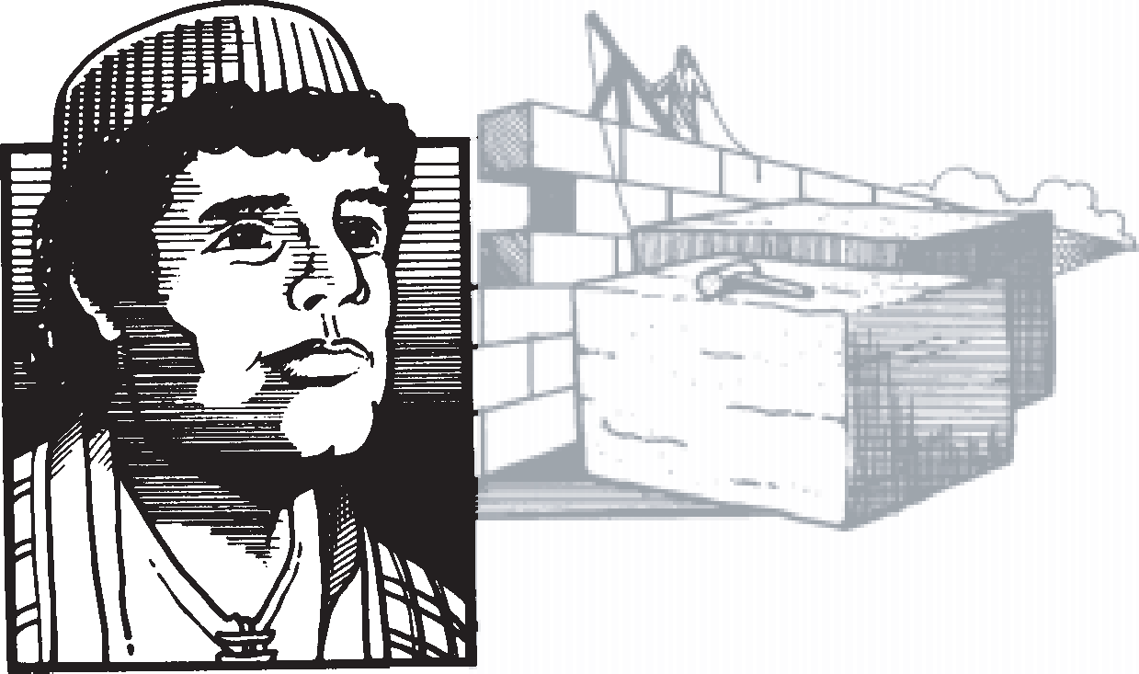
NEHEMIAH
In order to prepare for this study you must do a scouting report for the book of Nehemiah. Sure you could jump right into it but if you understand what is happening before you look at Nehemiah’s story its message will make a lot more sense. The ﬁrst thing you need to know is that in the Hebrew Bible (the Old Testament was mostly written in Hebrew) the books of Ezra and Nehemiah are together as one book. So as part of this scouting report you will seek to understand the book of Ezra. But before you get into Ezra you’ll start out looking at the book of Jeremiah. Consider the following questions and passages to discover the background to the book of Nehemiah.
- Read the following passages and answer these questions. Why were the people of God (Israel) in Babylon? How do you see God’s grace in the midst of judgment? What does God promise to his people?
Jeremiah 25:1-14
Jeremiah 29:1-14
Jeremiah chapters 32-34
Jeremiah 39:1-40:6

- Compare II Chronicles 35:15-23 with Ezra 1:2,3

The Scouting Report
- Read the book of Ezra and make an outline of the entire book. After completing your outline answer these questions:

  - Remember that in the Hebrew Bible Ezra and Nehemiah are one book instead of two. Why is it important to understand what happens in Ezra before you study Nehemiah?

  - Why does God command His people to rebuild the temple (the message of Ezra) as ﬁrst priority even over rebuilding the wall (the message of Nehemiah)?

  - What observations do you make from the book of Ezra? What challenges you from the book of Ezra?

  - Read Ezra 7:9,10. What is the reason that the good hand of God is on Ezra’s life? How can Ezra’s example motivate you to study the Scriptures this semester?

“The restoration of Israel, in their regathering to the homeland of Canaan, was important for various reasons. For Israel, it showed that God had not forgotten His promise to Abraham concerning the land of Canaan. (see Genesis 13:15) Hope for a missionary outreach to Gentiles was stirred up in the revival of true worship, for a key mission of Israel was to show heathen nations of the world what true worship of the true God was. And then, the restoration was directly related to the life and ministry of the coming Messiah, in the renewal of the Messianic promises. For example, Bethlehem, Nazareth and Zion were some of the geographical places woven into the promises concerning Jesus’ coming. In about four hundred years Jesus would be born of the seed of David in Bethlehem not in Babylon. The Holy Land of promise, not a land of captivity, was where His people would be dwelling when He would come unto them, ”His own ( John 1:11).” Jensen’s Survey of the Old Testament • Irving Jensen

A Survey of Nehemiah
Read
the book of Nehemiah at least a couple of times. Try reading in diﬀerent translations if you have them or read it the second time online at www.biblegateway.com.
the book of Nehemiah. Look for major divisions in the book also transitional words (like therefore). What would you title the entire book?
Outline

the major themes or recurring words or phrases. What challenges you from this book?
Observe

A Survey of Nehemiah
Summarize
    - The historical background of the book. Use a Bible handbook, Study Bible, Bible Dictionary, or a commentary. If none of these are available try investigation online at: http://www.blueletterbible.org/ or http://www.crosswalk.com/

    - What applications can you make from the book? What areas of application do you need to pay attention to as you study the book in depth?

- Make a chart to summarize what you have discovered in your survey. Make it on one sheet of paper. Use the chart on the following page or design your own. The value of such a chart is that it enables you to picture visually the contents and divisions of the book.
Teach

- Optional: As you are studying the book of Nehemiah pay attention to Nehemiah the leader. Look at the pages in the back of this study in the appendix to keep track of leadership principles you discover as you study the book.

A Survey of Nehemiah
NEHEMIAH
11

Survey | Book Title: | Author of Book |  | Time of Book
 | People in Book: |  |  | Places in Book:
 | Theme of Book: |  |  | Signiﬁcance of Book:
Titles
Chapters
Key Verses
Associations
 | Beginning of Book: |  | Ending of Book:
Themes

Chronology of Ezra, Nehemiah & Esther
(dates are approximate)

The decree of Cyrus to rebuild the temple. Zurubbabel’s expedition to Jerusalem.
538/7 BC
538 BC
536 BC
Foundation of the temple laid. Work on the temple halted.
535 BC
520 BC
Decree of Darius to resume work on the temple. Ministry of Haggai and Zechariah.
520 BC
516 BC
Temple completed.
Reign of Ahasuerus (Xerxes) begins. Esther crowned queen.
479/8 BC
486 BC
464 BC
Reign of Artaxerxes begins. Ezra’s expedition to Jerusalem. Nehemiah arrives in Jerusalem. Walls of Jerusalem completed.
458 BC
444 BC
444 BC
420 BC
Nehemiah’s second journey to Jerusalem.

The Temple and the Wall
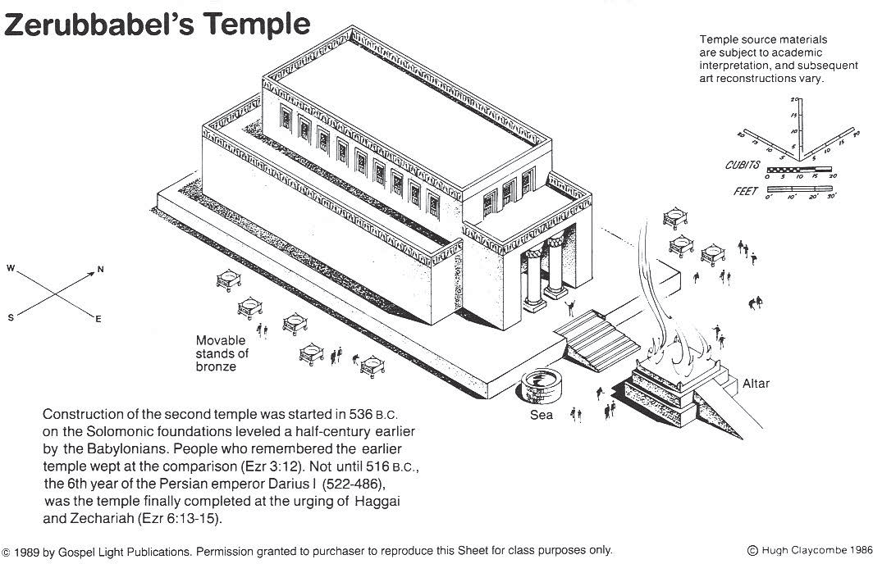
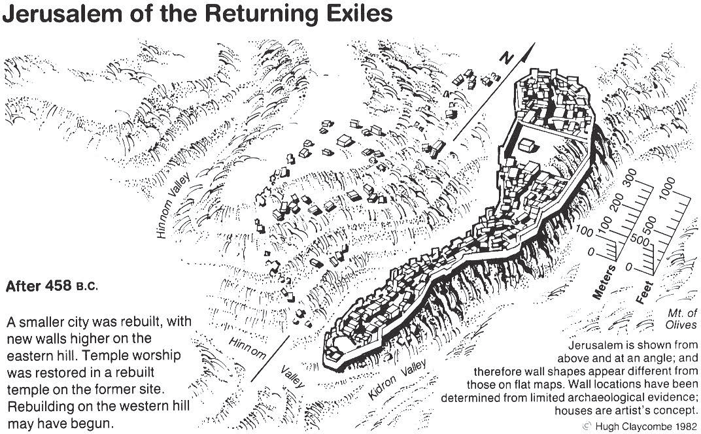

Observations
chapter 1
What does the passage say? Seek answers to the questions who, what, when, where and how? Look for information like
a detective would. Who are the people involved? What happened? What ideas are expressed? Where does this take place? When did it take place? What is the purpose? Are there any key words in the passage? Notice words like “but”, “if ” and “therefore”. What insight do they give you into the passage?

Questions & Investigation
chapter 1
What does the passage mean? Write out questions about what you don’t understand in the passage. Are there any words
or concepts you need to understand? What is the single primary meaning of the passage? Investigate answers to your questions ﬁrst by looking in the context and other passages of Scripture. Use other study resources like commentaries and dictionaries if necessary.

Illustration
chapter 1
Draw a picture or diagram to illustrate what you have discovered from this passage. How would you teach the truth of
this passage to someone else?

Application
As you are studying the passage pray that God will speak to you about what He wants you to do with what you are
learning from His Word. Write out an application below. Consider these questions: What is the truth from God’s Word that has challenged you? In what ways have I not lived according to God’s Word in this area? What will I do to live according to God’s Word? What will be the evidence that I have applied this truth? Who will keep me accountable?

Discussion Notes
chapter 1
Write down below what you learn from others in your study. What new insights do you gain? What was the major
emphasis for them? What are their applications of this passage?

Prayer Requests
Write down prayer requests from others in your group. If there is time spend some time praying for each other.

Observations
chapter 2
What does the passage say? Seek answers to the questions who, what, when, where and how? Look for information like
a detective would. Who are the people involved? What happened? What ideas are expressed? Where does this take place? When did it take place? What is the purpose? Are there any key words in the passage? Notice words like “but”, “if ” and “therefore”. What insight do they give you into the passage?

Questions & Investigation
chapter 2
What does the passage mean? Write out questions about what you don’t understand in the passage. Are there any words
or concepts you need to understand? What is the single primary meaning of the passage? Investigate answers to your questions ﬁrst by looking in the context and other passages of Scripture. Use other study resources like commentaries and dictionaries if necessary.

Illustration
chapter 2
Draw a picture or diagram to illustrate what you have discovered from this passage. How would you teach the truth of
this passage to someone else?

Application
As you are studying the passage pray that God will speak to you about what He wants you to do with what you are
learning from His Word. Write out an application below. Consider these questions: What is the truth from God’s Word that has challenged you? In what ways have I not lived according to God’s Word in this area? What will I do to live according to God’s Word? What will be the evidence that I have applied this truth? Who will keep me accountable?

Discussion Notes
chapter 2
Write down below what you learn from others in your study. What new insights do you gain? What was the major
emphasis for them? What are their applications of this passage?

Prayer Requests
Write down prayer requests from others in your group. If there is time spend some time praying for each other.

Observations
chapters 3,4
What does the passage say? Seek answers to the questions who, what, when, where and how? Look for information like
a detective would. Who are the people involved? What happened? What ideas are expressed? Where does this take place? When did it take place? What is the purpose? Are there any key words in the passage? Notice words like “but”, “if ” and “therefore”. What insight do they give you into the passage?

Questions & Investigation
chapters 3,4
What does the passage mean? Write out questions about what you don’t understand in the passage. Are there any words
or concepts you need to understand? What is the single primary meaning of the passage? Investigate answers to your questions ﬁrst by looking in the context and other passages of Scripture. Use other study resources like commentaries and dictionaries if necessary.

Illustration
chapters 3,4
Draw a picture or diagram to illustrate what you have discovered from this passage. How would you teach the truth of
this passage to someone else?

Application
As you are studying the passage pray that God will speak to you about what He wants you to do with what you are
learning from His Word. Write out an application below. Consider these questions: What is the truth from God’s Word that has challenged you? In what ways have I not lived according to God’s Word in this area? What will I do to live according to God’s Word? What will be the evidence that I have applied this truth? Who will keep me accountable?

Discussion Notes
chapters 3,4
Write down below what you learn from others in your study. What new insights do you gain? What was the major
emphasis for them? What are their applications of this passage?

Prayer Requests
Write down prayer requests from others in your group. If there is time spend some time praying for each other.

Observations
chapter 5
What does the passage say? Seek answers to the questions who, what, when, where and how? Look for information like
a detective would. Who are the people involved? What happened? What ideas are expressed? Where does this take place? When did it take place? What is the purpose? Are there any key words in the passage? Notice words like “but”, “if ” and “therefore”. What insight do they give you into the passage?

Questions & Investigation
chapter 5
What does the passage mean? Write out questions about what you don’t understand in the passage. Are there any words
or concepts you need to understand? What is the single primary meaning of the passage? Investigate answers to your questions ﬁrst by looking in the context and other passages of Scripture. Use other study resources like commentaries and dictionaries if necessary.

Illustration
chapter 5
Draw a picture or diagram to illustrate what you have discovered from this passage. How would you teach the truth of
this passage to someone else?

Application
As you are studying the passage pray that God will speak to you about what He wants you to do with what you are
learning from His Word. Write out an application below. Consider these questions: What is the truth from God’s Word that has challenged you? In what ways have I not lived according to God’s Word in this area? What will I do to live according to God’s Word? What will be the evidence that I have applied this truth? Who will keep me accountable?

Discussion Notes
chapter 5
Write down below what you learn from others in your study. What new insights do you gain? What was the major
emphasis for them? What are their applications of this passage?

Prayer Requests
Write down prayer requests from others in your group. If there is time spend some time praying for each other.

Observations
chapter 6
What does the passage say? Seek answers to the questions who, what, when, where and how? Look for information like
a detective would. Who are the people involved? What happened? What ideas are expressed? Where does this take place? When did it take place? What is the purpose? Are there any key words in the passage? Notice words like “but”, “if ” and “therefore”. What insight do they give you into the passage?

Questions & Investigation
chapter 6
What does the passage mean? Write out questions about what you don’t understand in the passage. Are there any words
or concepts you need to understand? What is the single primary meaning of the passage? Investigate answers to your questions ﬁrst by looking in the context and other passages of Scripture. Use other study resources like commentaries and dictionaries if necessary.

Illustration
chapter 6
Draw a picture or diagram to illustrate what you have discovered from this passage. How would you teach the truth of
this passage to someone else?

Application
As you are studying the passage pray that God will speak to you about what He wants you to do with what you are
learning from His Word. Write out an application below. Consider these questions: What is the truth from God’s Word that has challenged you? In what ways have I not lived according to God’s Word in this area? What will I do to live according to God’s Word? What will be the evidence that I have applied this truth? Who will keep me accountable?

Discussion Notes
chapter 6
Write down below what you learn from others in your study. What new insights do you gain? What was the major
emphasis for them? What are their applications of this passage?

Prayer Requests
Write down prayer requests from others in your group. If there is time spend some time praying for each other.

Observations
chapters 7,8
What does the passage say? Seek answers to the questions who, what, when, where and how? Look for information like
a detective would. Who are the people involved? What happened? What ideas are expressed? Where does this take place? When did it take place? What is the purpose? Are there any key words in the passage? Notice words like “but”, “if ” and “therefore”. What insight do they give you into the passage?

Questions & Investigation
chapters 7,8
What does the passage mean? Write out questions about what you don’t understand in the passage. Are there any words
or concepts you need to understand? What is the single primary meaning of the passage? Investigate answers to your questions ﬁrst by looking in the context and other passages of Scripture. Use other study resources like commentaries and dictionaries if necessary.

Illustration
chapters 7,8
Draw a picture or diagram to illustrate what you have discovered from this passage. How would you teach the truth of
this passage to someone else?

Application
As you are studying the passage pray that God will speak to you about what He wants you to do with what you are
learning from His Word. Write out an application below. Consider these questions: What is the truth from God’s Word that has challenged you? In what ways have I not lived according to God’s Word in this area? What will I do to live according to God’s Word? What will be the evidence that I have applied this truth? Who will keep me accountable?

Discussion Notes
chapters 7,8
Write down below what you learn from others in your study. What new insights do you gain? What was the major
emphasis for them? What are their applications of this passage?

Prayer Requests
Write down prayer requests from others in your group. If there is time spend some time praying for each other.

Observations
chapter 9
What does the passage say? Seek answers to the questions who, what, when, where and how? Look for information like
a detective would. Who are the people involved? What happened? What ideas are expressed? Where does this take place? When did it take place? What is the purpose? Are there any key words in the passage? Notice words like “but”, “if ” and “therefore”. What insight do they give you into the passage?

Questions & Investigation
chapter 9
What does the passage mean? Write out questions about what you don’t understand in the passage. Are there any words
or concepts you need to understand? What is the single primary meaning of the passage? Investigate answers to your questions ﬁrst by looking in the context and other passages of Scripture. Use other study resources like commentaries and dictionaries if necessary.

Illustration
chapter 9
Draw a picture or diagram to illustrate what you have discovered from this passage. How would you teach the truth of
this passage to someone else?

Application
As you are studying the passage pray that God will speak to you about what He wants you to do with what you are
learning from His Word. Write out an application below. Consider these questions: What is the truth from God’s Word that has challenged you? In what ways have I not lived according to God’s Word in this area? What will I do to live according to God’s Word? What will be the evidence that I have applied this truth? Who will keep me accountable?

Discussion Notes
chapter 9
Write down below what you learn from others in your study. What new insights do you gain? What was the major
emphasis for them? What are their applications of this passage?

Prayer Requests
Write down prayer requests from others in your group. If there is time spend some time praying for each other.

Observations
chapters 10,11
What does the passage say? Seek answers to the questions who, what, when, where and how? Look for information like
a detective would. Who are the people involved? What happened? What ideas are expressed? Where does this take place? When did it take place? What is the purpose? Are there any key words in the passage? Notice words like “but”, “if ” and “therefore”. What insight do they give you into the passage?

Questions & Investigation
chapters 10,11
What does the passage mean? Write out questions about what you don’t understand in the passage. Are there any words
or concepts you need to understand? What is the single primary meaning of the passage? Investigate answers to your questions ﬁrst by looking in the context and other passages of Scripture. Use other study resources like commentaries and dictionaries if necessary.

Illustration
chapters 10,11
Draw a picture or diagram to illustrate what you have discovered from this passage. How would you teach the truth of
this passage to someone else?

Application
As you are studying the passage pray that God will speak to you about what He wants you to do with what you are
learning from His Word. Write out an application below. Consider these questions: What is the truth from God’s Word that has challenged you? In what ways have I not lived according to God’s Word in this area? What will I do to live according to God’s Word? What will be the evidence that I have applied this truth? Who will keep me accountable?

Discussion Notes
chapters 10,11
Write down below what you learn from others in your study. What new insights do you gain? What was the major
emphasis for them? What are their applications of this passage?

Prayer Requests
Write down prayer requests from others in your group. If there is time spend some time praying for each other.

Observations
chapter 12
What does the passage say? Seek answers to the questions who, what, when, where and how? Look for information like
a detective would. Who are the people involved? What happened? What ideas are expressed? Where does this take place? When did it take place? What is the purpose? Are there any key words in the passage? Notice words like “but”, “if ” and “therefore”. What insight do they give you into the passage?

Questions & Investigation
chapter 12
What does the passage mean? Write out questions about what you don’t understand in the passage. Are there any words
or concepts you need to understand? What is the single primary meaning of the passage? Investigate answers to your questions ﬁrst by looking in the context and other passages of Scripture. Use other study resources like commentaries and dictionaries if necessary.

Illustration
chapter 12
Draw a picture or diagram to illustrate what you have discovered from this passage. How would you teach the truth of
this passage to someone else?

Application
As you are studying the passage pray that God will speak to you about what He wants you to do with what you are
learning from His Word. Write out an application below. Consider these questions: What is the truth from God’s Word that has challenged you? In what ways have I not lived according to God’s Word in this area? What will I do to live according to God’s Word? What will be the evidence that I have applied this truth? Who will keep me accountable?

Discussion Notes
chapter 12
Write down below what you learn from others in your study. What new insights do you gain? What was the major
emphasis for them? What are their applications of this passage?

Prayer Requests
Write down prayer requests from others in your group. If there is time spend some time praying for each other.

Observations
chapter 13
What does the passage say? Seek answers to the questions who, what, when, where and how? Look for information like
a detective would. Who are the people involved? What happened? What ideas are expressed? Where does this take place? When did it take place? What is the purpose? Are there any key words in the passage? Notice words like “but”, “if ” and “therefore”. What insight do they give you into the passage?

50 NEHEMIAH

Questions & Investigation
chapter 13
What does the passage mean? Write out questions about what you don’t understand in the passage. Are there any words
or concepts you need to understand? What is the single primary meaning of the passage? Investigate answers to your questions ﬁrst by looking in the context and other passages of Scripture. Use other study resources like commentaries and dictionaries if necessary.

Illustration
chapter 13
Draw a picture or diagram to illustrate what you have discovered from this passage. How would you teach the truth of
this passage to someone else?

Application
As you are studying the passage pray that God will speak to you about what He wants you to do with what you are
learning from His Word. Write out an application below. Consider these questions: What is the truth from God’s Word that has challenged you? In what ways have I not lived according to God’s Word in this area? What will I do to live according to God’s Word? What will be the evidence that I have applied this truth? Who will keep me accountable?

Discussion Notes
chapter 13
Write down below what you learn from others in your study. What new insights do you gain? What was the major
emphasis for them? What are their applications of this passage?

Prayer Requests
Write down prayer requests from others in your group. If there is time spend some time praying for each other.

A Summary of Nehemiah
Review
your survey of Nehemiah (pages 9-13) and review your study of Nehemiah (weeks 3-12).

the book of Nehemiah.
Reread

the whole book. Using your initial book outline and your notes from your chapter studies make an outline for the book. Don’t necessarily limit yourself to chapter or verse divisions.
Outline

A Summary of Nehemiah
Relate
the message of Nehemiah to today. What is its signiﬁcance?

the message of Nehemiah to your life. List your applications. Take time to reﬂect, pray and journal on what you learned from your time in Nehemiah. What in God’s message ought you to conform your life to, and what steps will you take to see that happen?
Apply

- Make a chart to summarize what you have discovered in your sumary. Make it on one sheet of paper. Use the chart on the following page or design your own. The value of such a chart is that it will be a valuable reference tool when you refer back to lessons you learned from Nehemiah in the future.
Chart

A Summary of Nehemiah
56 NEHEMIAH
Summary | Book Title: | Author of Book: | Key Verse:
 | Theme of Book: |  | Significance of Book:
Titles
Chapters
Key Verses
Book Outline and/or Summary
Applications
Major Lessons and Challenges
Key Sections for Teaching

A Summary of Nehemiah
Create
an illustration or teaching tool to communicate the truths of Nehemiah to someone else.

about what God has taught you through the book of Nehemiah. Pray over your applications. Consider Nehemiah’s faith. What “wall” is God calling you to build?
Pray

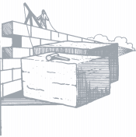KEY PASSAGES: Nehemiah 1:1-7:3; 13:1-31

“Come, let us rebuild the wall of Jerusalem” • NEHEMIAH 2:17
NIV

THE CHARACTER OF INDUSTRY

MEANING OF HIS NAME
Nehemiah's name in Hebrew means "Comfort of Jehovah"
- What is the signiﬁcance of Nehemiah’s name? In what ways does Nehemiah live up to the meaning of his name?

EXPERIENCE
- What was Nehemiah’s life experience? What do we know about his father, mother, tribe, nation? What time did he live in? What are the signiﬁcant periods of his life? What about his occupation, contemporaries or associates?

SPIRITUAL LIFE
  - What do you observe about Nehemiah’s prayer life, obedience, suﬀering, personal lessons from God, attitudes, responses and reactions? What growth or maturity do you see in his life?

SHORTCOMINGS
  - Do you observe any weaknesses in Nehemiah’s life? What reasons would you give for the presence of these weaknesses?

ACCOMPLISHMENTS
- What strengths do you see in Nehemiah’s life and character? Are there any key or unique phrases used in describing him?

GLORY TO GOD
- How is God honored through Nehemiah’s life? Are there any particular attributes of God that are especially revealed through Nehemiah? What is Nehemiah’s concept of God and how does he relate to Him?

ESSENTIAL TRUTH
  - How does Nehemiah model the character of industry (working hard and well)? (List references below) What can you learn about industry from Nehemiah’s life?

LIFE APPLICATION

L LEADING LESSON

I IMPACT ON YOUR LIFE

F FUTURE PLANS

E EXPRESS OBEDIENCE
- What do you think is the leading lesson of Nehemiah’s life?

- How does the leading lesson impact your life? What speciﬁc changes do you need to make to become a person of like character?

- What speciﬁc action do you plan to take to grow in this area of character?

- Write out a prayer below expressing to God your desire to be obedient in this area of your life.

Leadership Principles in Nehemiah
As you are studying the book of Nehemiah and discover a principle of good leadership list the reference of the verse(s), where the principle is found, make any observations and state the principle.

REFERENCE OBSERVATIONS PRINCIPLE

Leadership Principles in Nehemiah
REFERENCE OBSERVATIONS PRINCIPLE

Leadership Principles in Nehemiah
REFERENCE OBSERVATIONS PRINCIPLE

Leadership Principles in Nehemiah
REFERENCE OBSERVATIONS PRINCIPLE

Leadership Principles in Nehemiah
REFERENCE OBSERVATIONS PRINCIPLE

